
Rustington Heritage Association

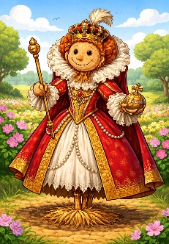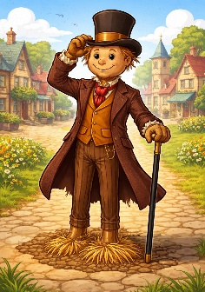

“Scarecrows through the Ages”
Scarecrow Trail 2026 Entry Form

Is your entry as an Individual or Organisation?
(delete as appropriate)

Name:

Address:

Main Contact:

Email & phone:

Site of scarecrow(s):

Are you willing to allow photographs of the scarecrow(s) to be taken and used for advertising and promotion? Yes/No

I/we have read and agree to the T's & C's

Signed (Authorised Representative):

PLEASE RETURN TO THE PARISH COUNCIL OFFICE OR THE SAMUEL WICKENS CENTRE OR EMAIL: Contactrustyha@gmail.com

Please note that personal information will only be used in connection with the trail, and for no other purposes. It will be held for the duration of the event only, and then destroyed.

